Ward Panel Report

Herne Hill

Tuesday 7th of March 2017

Commissioned By | PS Sincock 4LX
Protective Marking | Not Protectively Marked
Suitable for the Publication Scheme Y/N | N
Purpose | To inform ward panel members of current crime within the ward
Branch, OCU and Operational Command | Lambeth Borough
Author | PS Sincock 4LX
Date Created | 07/03/2017

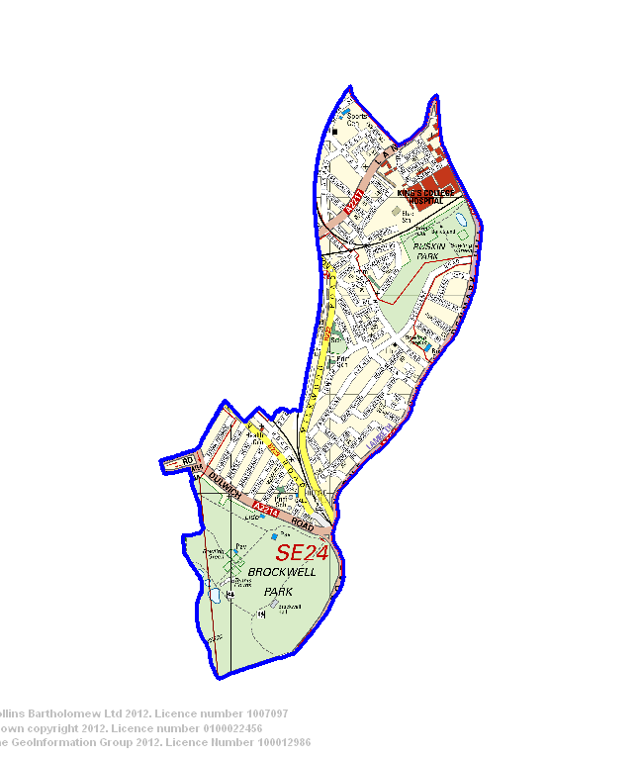

Introduction

Purpose

Create a report for Herne Hill Safer Neighbourhoods Team to show the main crime figures within the ward.

Methodology

Total Notifiable Offences (TNO’s) have been extracted for the period Dec 2016 – Feb 2017 from the Total Policing, Digital Policing Business Analytics- SNT Analytics This shows crime that has been reported and classified on the Metropolitan Police Crime Database (CRIS).

Limitations

The information is limited by the accuracy of the information that has been entered into the respective databases.

TEAM NEWS

DWO PC Simms has left to join Brixton Contest Team

DWO PC McGeever has transferred to Derbyshire Police

PC Bellenie has transferred to MetCC

Two new PC’s are joining on 27th of March, both will undertake roles as Herne Hill DWO’s one permanently and the other covering PC Simpson’s maternity leave.

Current Team Structure

Insp Rutland

PS Sincock (Coldharbour and Herne Hill)

Coldharbour DWO’s Herne Hill DWO’s
PC Ollie Cahill-Smith PC Vicky Simpson
PC Nadira Hassan TBC
PCSO Marcia Reynolds PCSO Mo Kennah
PCSO Darren Firth

CRIME STATISTICS

Burglary


Feb 2016 | Mar 2016 | Apr 2016 | May 2016 | Jun 2016 | Jul 2016 | Aug 2016 | Sep 2016 | Oct 2016 | Nov 2016 | Dec 2016 | Jan 2017
22 | 22 | 23 | 17 | 18 | 31 | 16 | 12 | 27 | 20 | 8 | 21

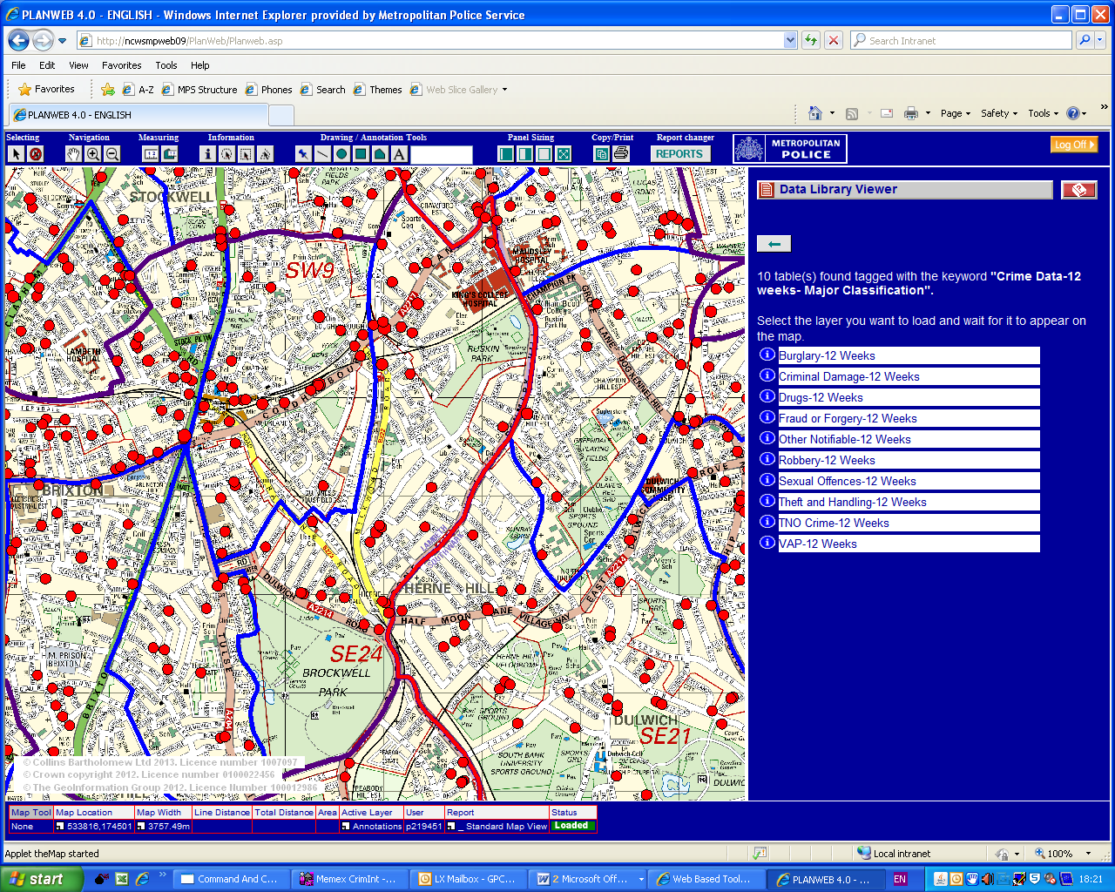

Robbery

Feb 2016 | Mar 2016 | Apr 2016 | May 2016 | Jun 2016 | Jul 2016 | Aug 2016 | Sep 2016 | Oct 2016 | Nov 2016 | Dec 2016 | Jan 2017
2 | 3 | 4 | 3 | 3 | 6 | 5 | 4 | 4 | 3 | 4 | 5

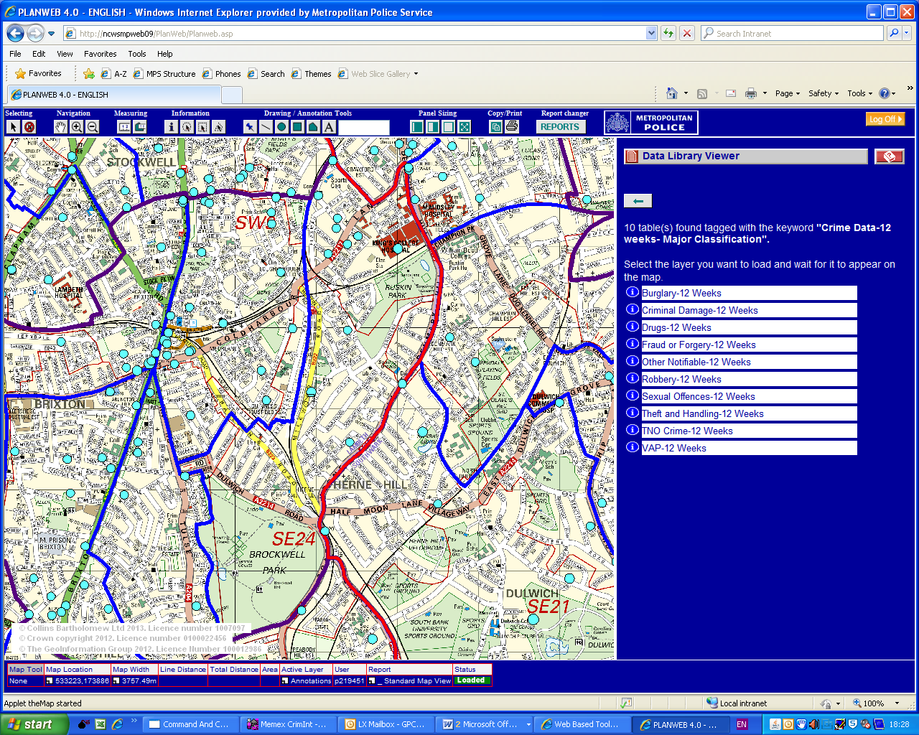

Assault with injury

Feb 2016 | Mar 2016 | Apr 2016 | May 2016 | Jun 2016 | Jul 2016 | Aug 2016 | Sep 2016 | Oct 2016 | Nov 2016 | Dec 2016 | Jan 2017
12 | 3 | 13 | 13 | 11 | 16 | 12 | 4 | 9 | 8 | 8 | 8

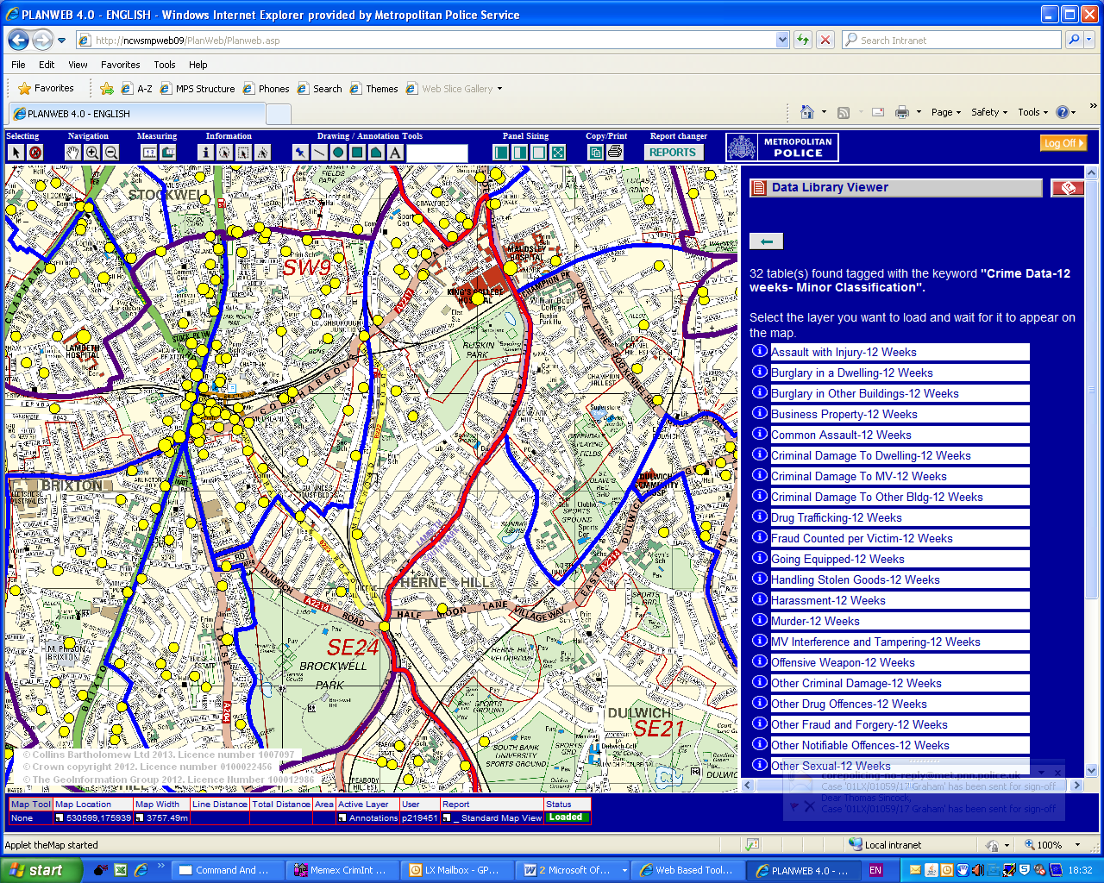

Theft from Motor Vehicle

Feb 2016 | Mar 2016 | Apr 2016 | May 2016 | Jun 2016 | Jul 2016 | Aug 2016 | Sep 2016 | Oct 2016 | Nov 2016 | Dec 2016 | Jan 2017
2 | 11 | 9 | 6 | 12 | 8 | 7 | 7 | 3 | 2 | 4 | 1

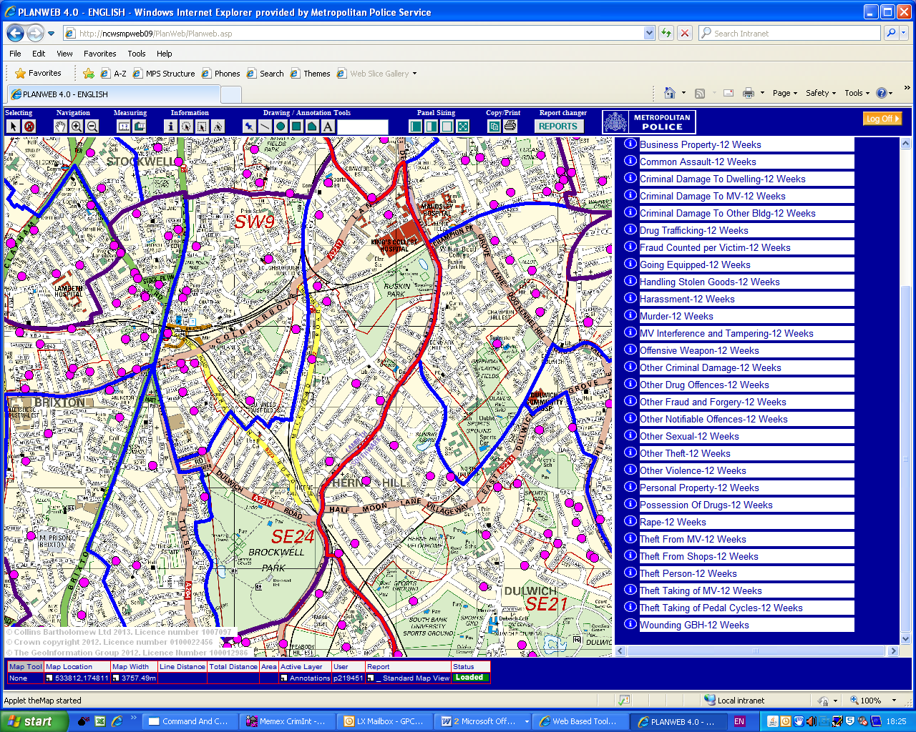

What has been done since the last ward panel?

Closure Orders: One currently in progress.

Warrants: 4 Drugs warrants executed. One of which resulted in over £30,000 in cash being seized and over 1 Kg of uncut cocaine being seized valued at approx £50,000. One suspect was arrested at the scene and since been charged and remanded at court for PWITS Class A and POCA offences

Vulnerable Panel: One child currently being mentored by the panel.

Criminal Behaviour Orders - One Community Protection Notice issued. Two CBO’s pending and awaiting court appearances.

Evictions and Disclosures - Two disclosures completed for housing associations resulting from above warrants awaiting decisions.

Weapons: Daily weapons sweeps conducted resulting four knifes found and seized by PCSO Mo.

Other: Planning under way for summer events taking place in Brockwell Park to provide events with police presence. (Sunfall, Lambeth Country Fair etc)

Developing Issues

- Moped enabled robberies

Ward promises and priorities

Ward priorities:

- Anti social behaviour in general
- Drug dealing a drug use
- Violence with injury

Current promises set from the previous ward panel meeting:

- Road Safety
- Theft from Motor Vehicles
- Anti-Social behaviour in general.

New promises..?

CONTACT DETAILS

236 Coldharbour Lane SW98SD
HerneHill.snt@met.police.uk
thomas.sincock@met.police.uk
0208 6492007
101/999

SAFER NEIGHBOURHOODS CRIME DATA
(Updated October 2016)
This includes crime data for all notifiable crimes that have been classified and
Confirmed as such according to Home Office counting rules.
WARNING
These are not the complete classified and confirmed crimes for
the ward. Not all crimes have a geographical location (e.g. those shown as committed in the Central
Criminal Court (CCC) Area.) and not all crimes have a location that can be pin-pointed on a map. This
means that some particular crimes cannot be allocated to a geographical ward boundary and as such will
not appear in these figures. Approximately 10% of crime comes into those categories. This varies from
crime type to crime type and from one borough to the next.

