Survey for Wyck Gardens
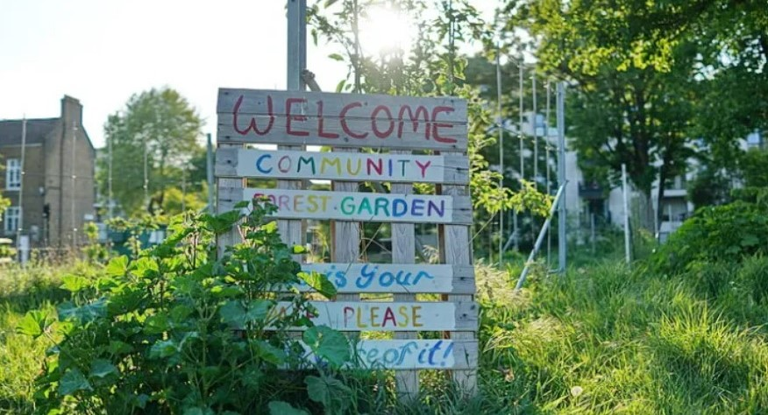
Friends of Wyck Gardens and Loughborough Farm organise regular volunteering activities in the park. We would be very grateful if you could help us by filling in our survey.
Scan the QR code  below to access our  survey on your mobile  phone.  (It is anonymous so  no email or number  required) | Orchard Sessions  The orchard sessions in Wyck Forest Garden run by Loughborough Farm are managed by Heather Seal.  Email: wyckforestgarden@gmail.com  Instagram @wyckforestgarden
 | Friends of Wyck Gardens  Friends of Wyck Gardens(FWG) do litter picking and path maintenance. Managed by Jan and Adam.  Email: friendsofwyckgardens@mail.com  Instagram @friends_wyck_gardens
Your opinion matters to us!

