

Code of Conduct

LJAG encourages and supports a safe, inclusive and pleasant work environment. This can only happen when everyone,

- co-operates
- is respectful of others
- shows integrity and professionalism at work and
- commits to appropriate standards of behaviour.

This Code of Conduct applies to
Everyone irrespective of their status or rank in the organisation. A copy of the code of conduct will be given to every member of staff. We will go through the code of conduct with staff at induction and it will be discussed during team meetings.

Unacceptable Behaviours
The following are the list of behaviours we consider unacceptable. Any employee found engaging in such behaviours will be subject to disciplinary actions including reprimand, warning or even dismissal.

- Failure to be at work, ready to work, at the regular starting time.
- Wilfully damaging, destroying or stealing property belonging to a fellow employee or the organisation
- Fighting or engaging in disorderly conduct
- Refusing or failing to carry out instructions given by your line manager/supervisor
- Leaving your workspace for long periods of time without permission (unless for reasonable personal needs)
- Coming to work under the influence of alcohol or any drug or bringing them into the work environment.
- Intentionally giving false or misleading information to obtain employment or a leave of absence
- Bullying, victimising, discriminating or harassing a colleague or service user.
- Sexual, homophobic, racially motivated abuse, attacks or unwanted behaviours
- Using threatening or abusive language towards colleagues
- Violating health and safety, or safeguarding policy or regulations
- Not taking proper care of, or neglecting the organisation’s property
- Using the organisation’s premises and equipment in an unauthorised manner
- Posting organisational related content on social media without express permission/agreement from the organisation
- Being irresponsible with the organisation’s finances, products, services, partnerships and public image.
- Taking bribes for personal benefit or for an external or internal party.
- Regularly turning up late and failing to let us know if you are going to be absent

The policy was created: 6 June 2022
Signed off by Kate Fielding on 20th July 2022, Co-ops UK. The policies will be reviewed in June 2024.

We update the policy as and when there are any changes in regulations and any learning from the organisation.

Important Note
The review of the policy started on 9 February 2024 by HR Consultancy (Kate Fielding), to finalise review and update by 5 June 2024.

Date Created | Initial Review by HR consultancy | Second review by LJAG and HR consultancy | Document Version | Approved by Trustees | Next Review Date
6 June 2022 |  |  | 1 | 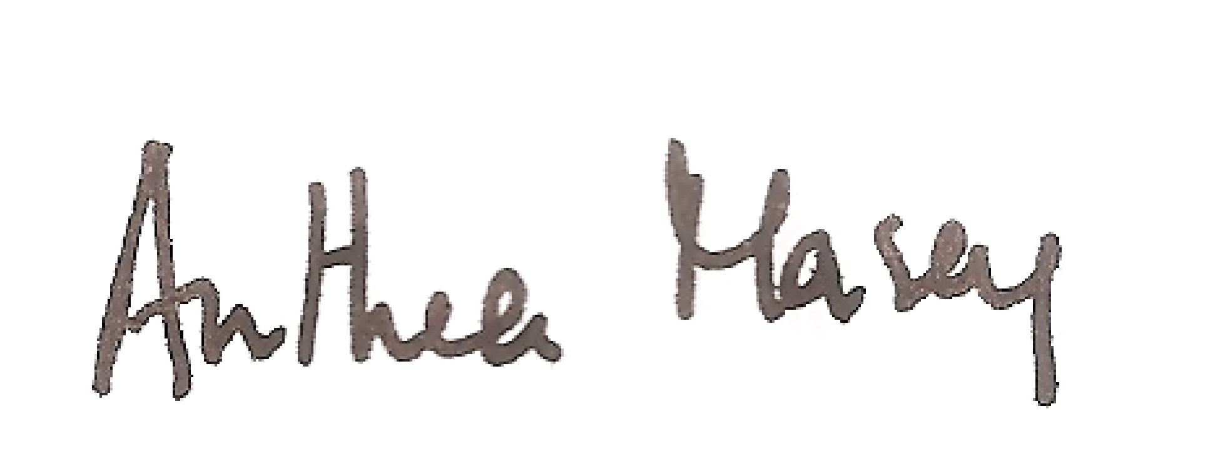 | 5 June 2024
 | 9 February 2024 |  | 2 |  | 5 June 2026

