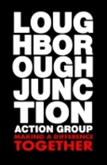

Dignity at Work Policy

Context

There is no place at LJAG for any form of discrimination, harassment, victimisation or sexual misconduct. Such behaviours contradict our values and diminishes the dignity of everyone involved with LJAG.

LJAG will ensure to the best of its ability that no group or individual will be discriminated against because of their responsibility for dependents, their health, employment status, learning ability, size, social class or caste or their protected characteristic, as set out under the Equality Act 2010. The protected characteristics cover:

- Age
- Disability
- Gender reassignment
- Marriage and Civil Partnership
- Pregnancy and Maternity
- Race (including ethnic origin, nationality and colour)
- Religion or Belief
- Sex
- Sexual Orientation

Definitions

- Direct discrimination: treating someone less favourably because of a Protected Characteristic. For example, rejecting a job applicant because of their religious views or sexual orientation;
- Indirect discrimination: a provision, criterion or practice that applies to everyone but adversely affects people with a particular Protected Characteristic more than others, and is not justified;
- Harassment: this includes sexual harassment and other unwanted conduct related to a Protected Characteristic, which has the purpose or effect of violating someone's dignity or creating an intimidating, hostile, degrading, humiliating or offensive environment for them;
- Sexual misconduct is any conduct that is sexual, unwanted and causes distress, or that otherwise constitutes harassment, bullying or victimisation.
- Victimisation: retaliation against someone who has complained or has supported someone else's complaint about discrimination or harassment;
- Disability discrimination: this includes direct and indirect discrimination, any unjustified less favourable treatment because of the effects of a disability.

LJAG’s dignity at work policy aims to

- Support an inclusive and positive working environment for everyone, free from inappropriate, demeaning and unacceptable behaviours;
- Make it clear that harassment, bullying and discrimination are unacceptable. We are all responsible for creating an environment and culture which is free from bullying, discrimination and harassment;
- Provide a framework for respect and good conduct at work so we can prevent and eliminate inappropriate and demeaning behaviours;
- Highlight options available to staff, volunteers, trustees and everyone involved with us who feel they have been subject to bullying, harassment, discrimination, sexual misconduct, or any other inappropriate or unacceptable behaviour;
- Establish a mechanism by which complaints can be addressed in a timely, professional and inclusive manner;
- Set out responsibilities for managing and supporting staff when they raise any concerns under our dignity at work policy.

We each have a personal responsibility to
- Treat others with dignity and respect
- Discourage and challenge any form of discrimination, harassment, bullying or inappropriate behaviours and make it clear that such behaviours are unacceptable. Where this happens LJAG will deal with these issues in line with relevant policies such as our bullying and harassment and disciplinary policies
- Support anyone who has been at the receiving end of such behaviours, including supporting them to make a formal complaint
- Managers and project leads have a particular responsibility for setting standards and ensuring appropriate workplace behaviours are maintained. They should set a good example and ensure concerns raised are acted upon.
The Dignity at Work Policy does not form part of and is not intended to vary the contract of employment or worker’s contract. It may be amended from time to time, as necessary.

Date Created | Date Reviewed | Document Version | Approved by Trustees | Next Review Date
6 June 2022 | 6 June 2022 | 1 | 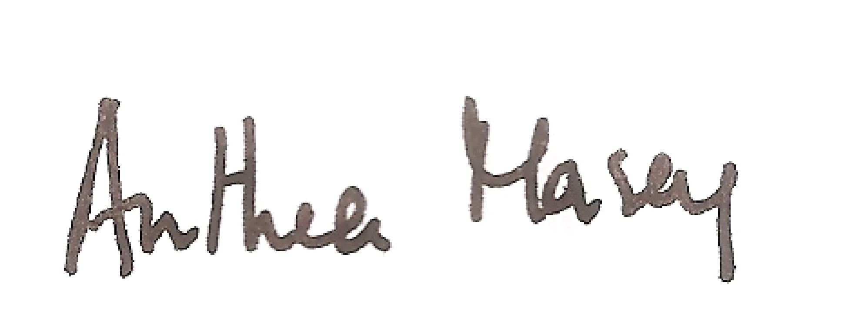 | 5 June 2024

